Practical - 11
Student Management CRUD with Search and Filter
Problem Definition: Create a student management module to add, view, edit, delete, search and filter student records. All database operations must use MySQLi statements and clear success/failure messages.

A. Theory
1. What is CRUD?
Answer: CRUD stands for Create, Read, Update, and Delete. These operations cover the basic lifecycle of database records.
2. Why use MySQLi prepared statements?
Answer: Prepared statements help keep user-provided values separate from SQL syntax and reduce SQL injection risk.
3. How do search and filter differ?
Answer: Search matches a user-entered phrase across selected fields. A filter restricts results using a condition such as course or status.
4. Why confirm deletion?
Answer: Confirmation helps prevent accidental removal. The server must still validate the record ID and permissions.

B. Implementation / Procedure
1. Database setup
Create a students table with id, name, email, course, phone, and created_at. Add suitable constraints, including a unique email if appropriate.
2. Create and Read
Use validated POST input and prepared INSERT statements to add records. Use SELECT to display students in a table.
3. Update
Load the selected record by ID, populate an edit form, validate submitted changes, and execute a prepared UPDATE statement.
4. Delete
Confirm the action in the interface, then send a POST request. Validate the ID and execute a prepared DELETE statement only for authorized users.
5. Search and filter
Use prepared SELECT queries with LIKE conditions for name/email/course and an optional course filter. Escape displayed values with htmlspecialchars().

C. Test Cases
Test Case | Input / Action | Expected Result
Add student | Submit valid student details | New record appears in the list
Edit student | Change course or phone | Updated values appear
Delete student | Confirm delete for a record | Record is removed and success message appears
Search | Search a known name/email | Only matching records are shown
Filter | Choose a course | Only students in that course are shown

D. Key Questions / Analysis / Interpretation
1. Are SELECT, INSERT, UPDATE, and DELETE operations working?
Answer: SELECT displays records, INSERT adds a student, UPDATE edits an existing record, and DELETE removes a record after confirmation. Each operation reports success or failure.
2. Is search by name/email/course implemented?
Answer: A search field can match name, email, or course using a prepared query. A course filter can narrow the results further.
3. Are delete operations confirmed before execution?
Answer: Yes. A confirmation prompt is shown before the delete request is submitted to prevent accidental deletion.

Work (Screenshots)
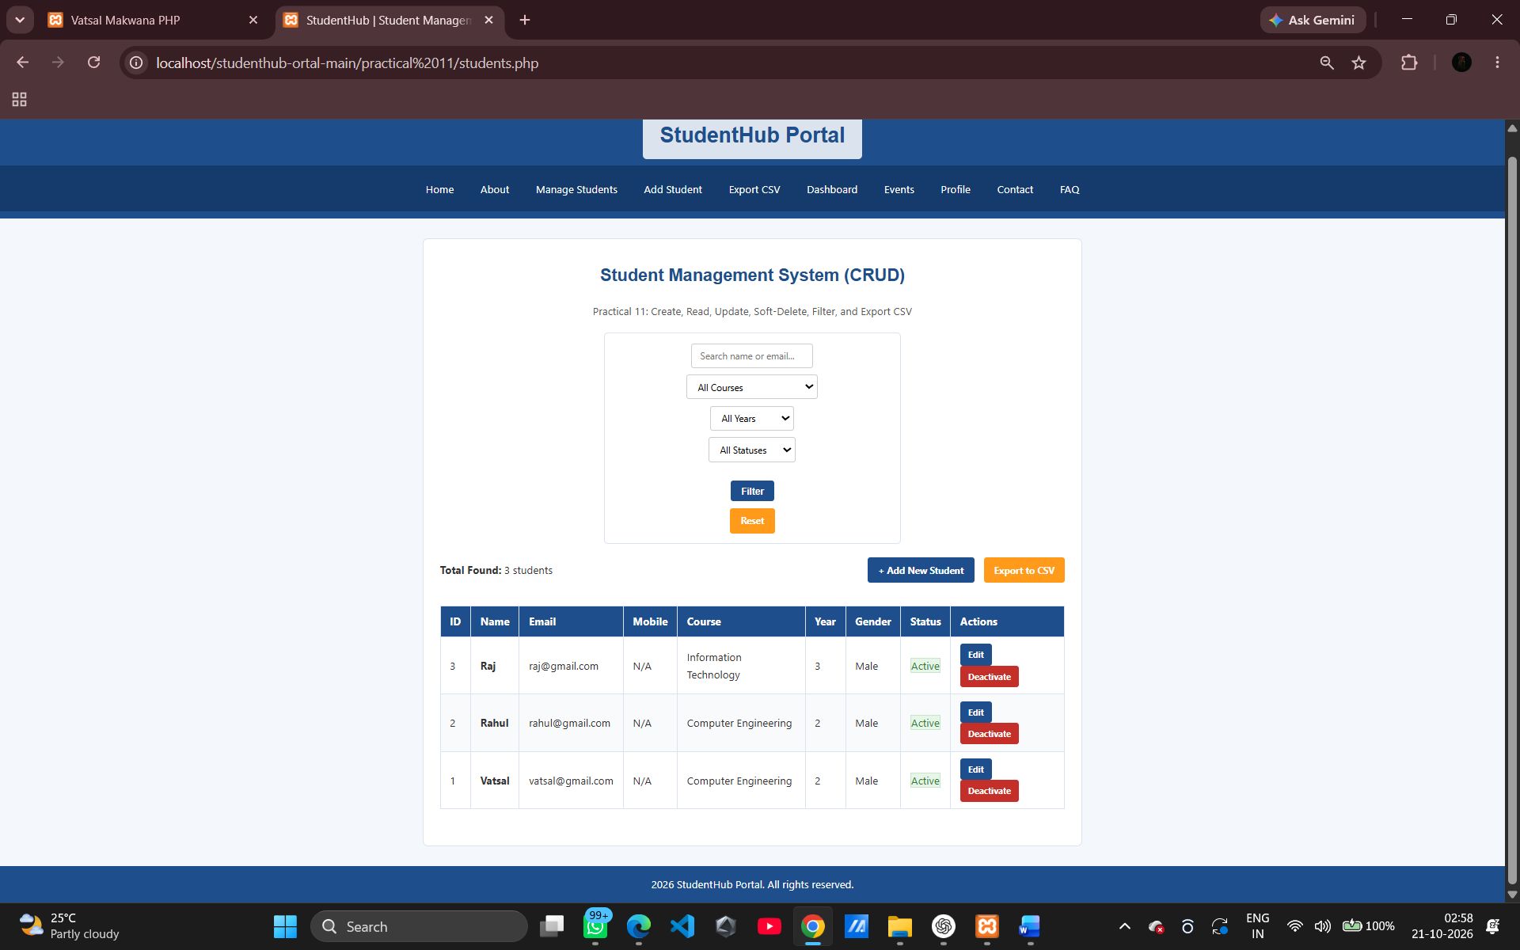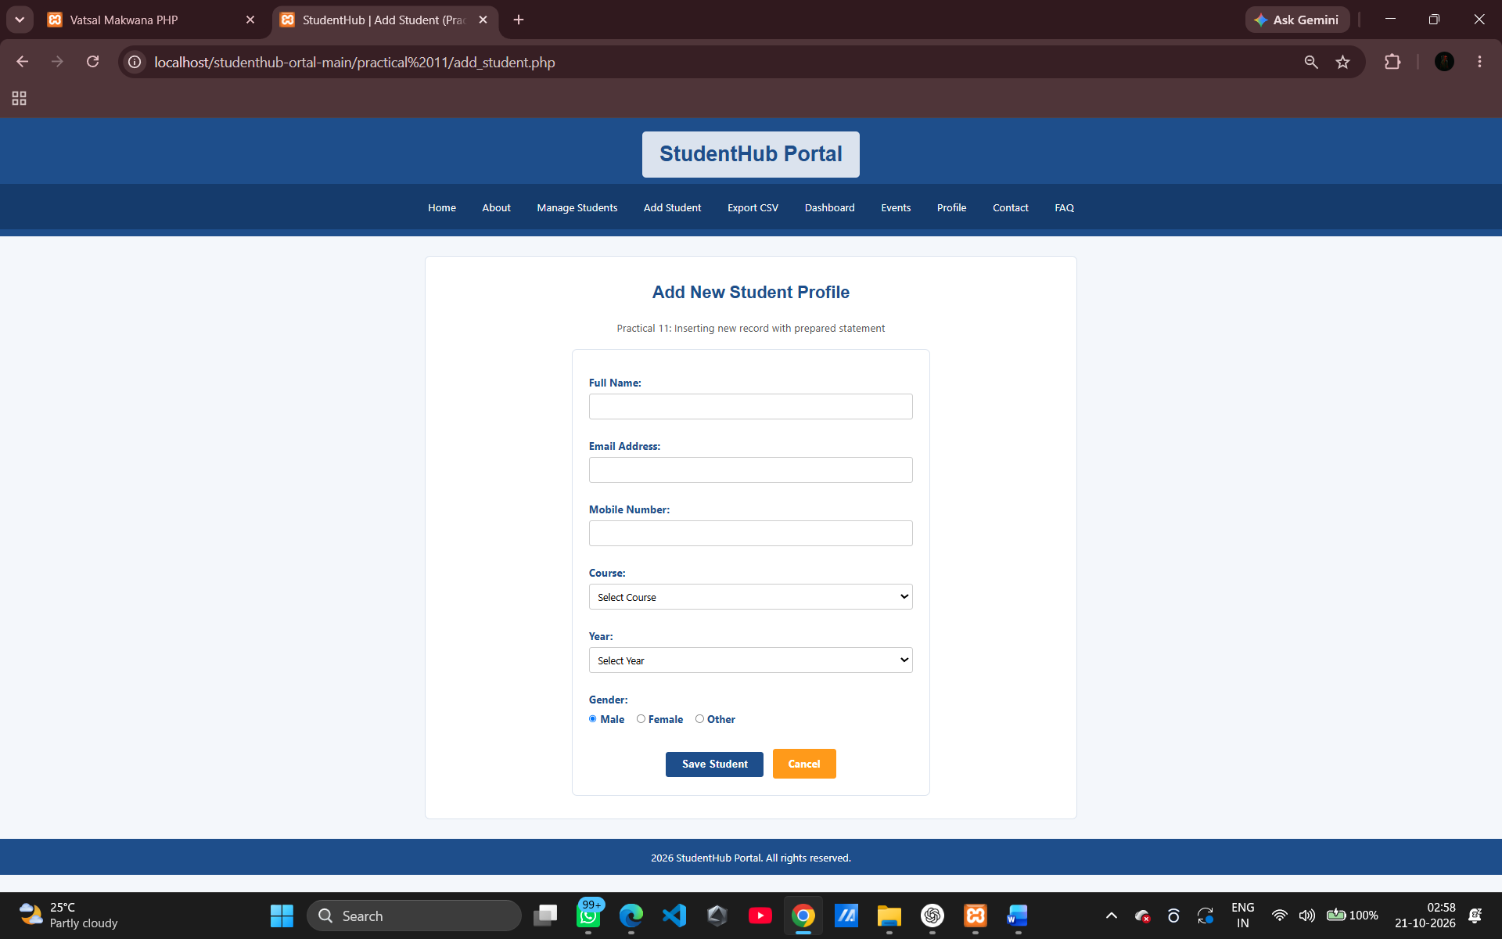

N. GitHub Repository Link
https://github.com/archibhatt091601/studenthub-ortal

